Lab Assignment-6

ECSE373L: Cloud Infrastructure and Services

**Name:** Tanvi Penumudy

**Enroll no**: E18CSE187

**Batch:** EB02

**Lab Activities:**

**Task 0:** Create the IAM Role of Full DynamoDB and CloudWatch service using IAM service.

**Task 1:** Create Lambda function and provide the created role as in task 0.

**Task 2:** Write the code in the Lambda function as given in sample code.

**Task 3:** Go to DynamoDB database service of AWS and Create a table named as weather and key name as city.

**Task 4:** Create the items in the weather table or you can fill automatically.

**Example:**

|  |  |
| --- | --- |
| City | Temp |
| Delhi | 18 |
| Mumbai | 25 |
| London | 5 |
| Italy | 3 |

**Task 5:** Create an Amazon API Gateway by selecting REST Architecture. API name you can choose as per your choice. (Endpoint type should be regional)

**Task 6:** Then Create API resource (any relevant name you can give)

**Task 7:** Create a GET method and select Lambda function as integration type and tick the Use Lambda Proxy Integration then provide the created Lambda function name.

**Task 8:** Now deploy the API.

**Task 9:** Then Test the deployed API by using invoke URL of API.

**Task 10:** Take the snapshots of all performed tasks and create a doc/pdf of your enrolment number_lab06 and upload the file on LMS.

**Task 0**

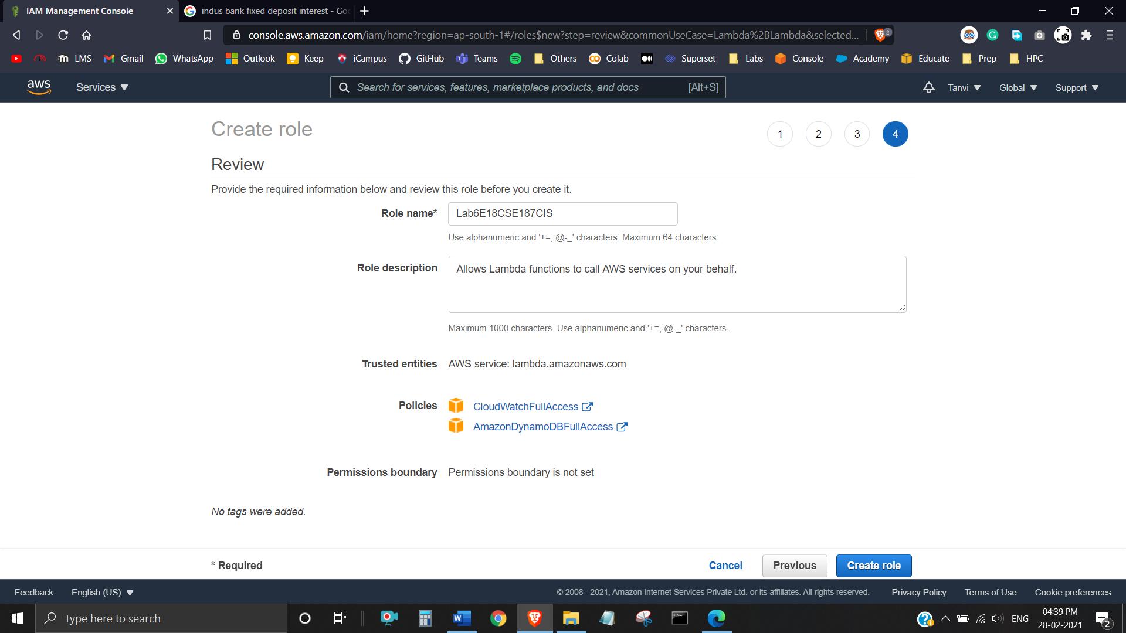

**Task 1**

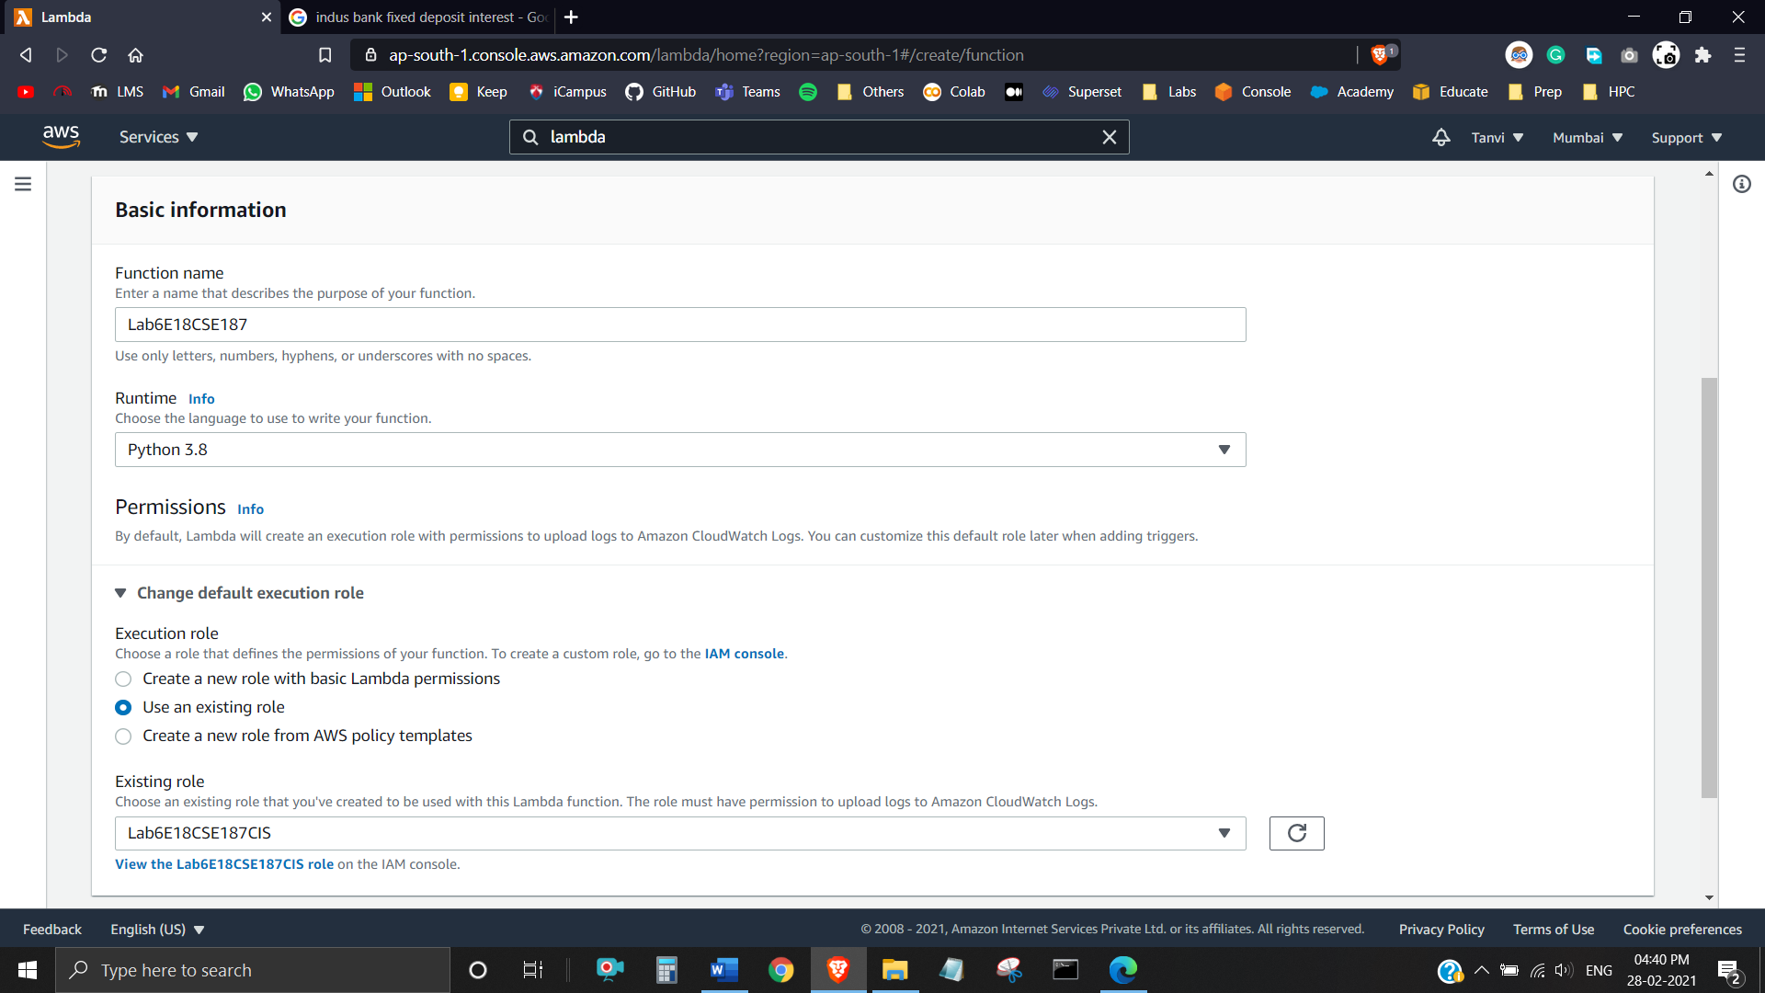

**Task 2**

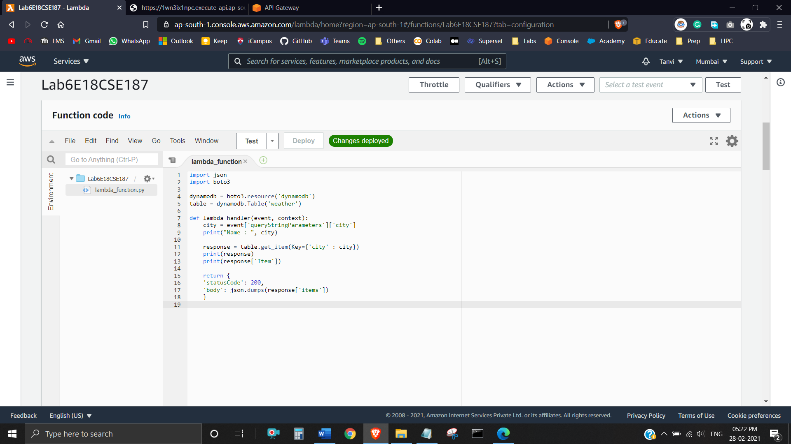

**Task 3**

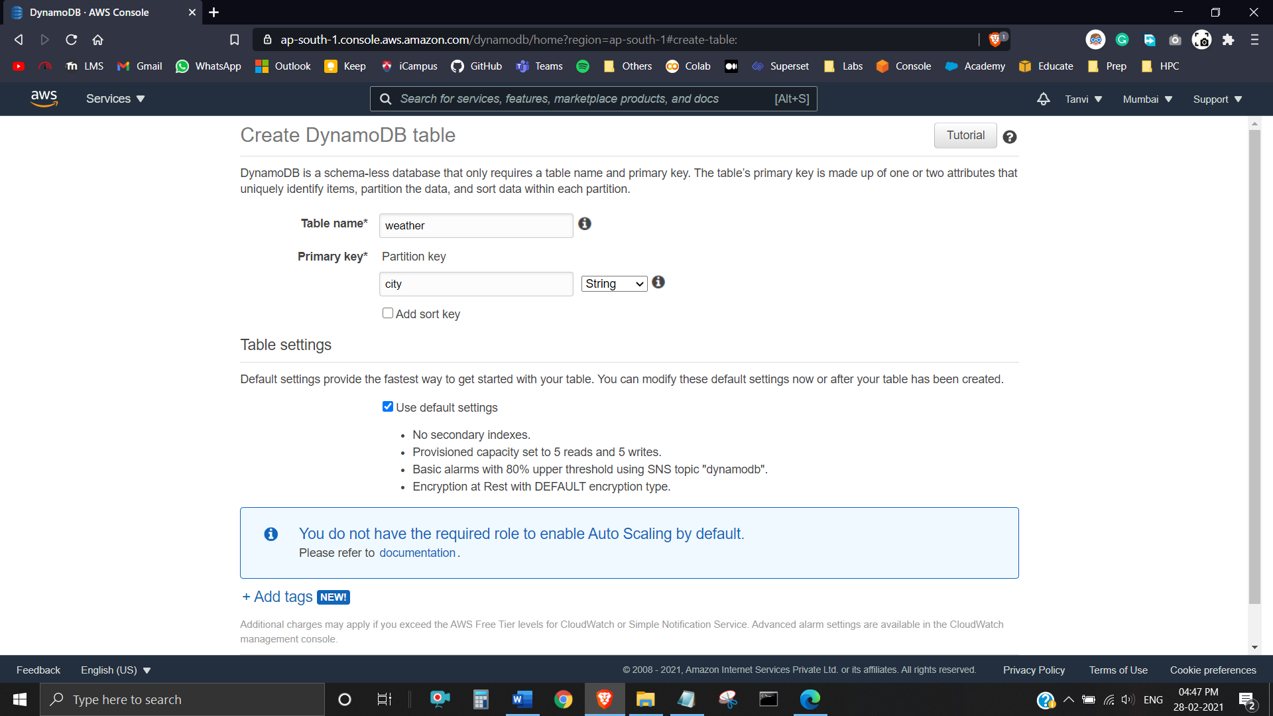

**Task 4**

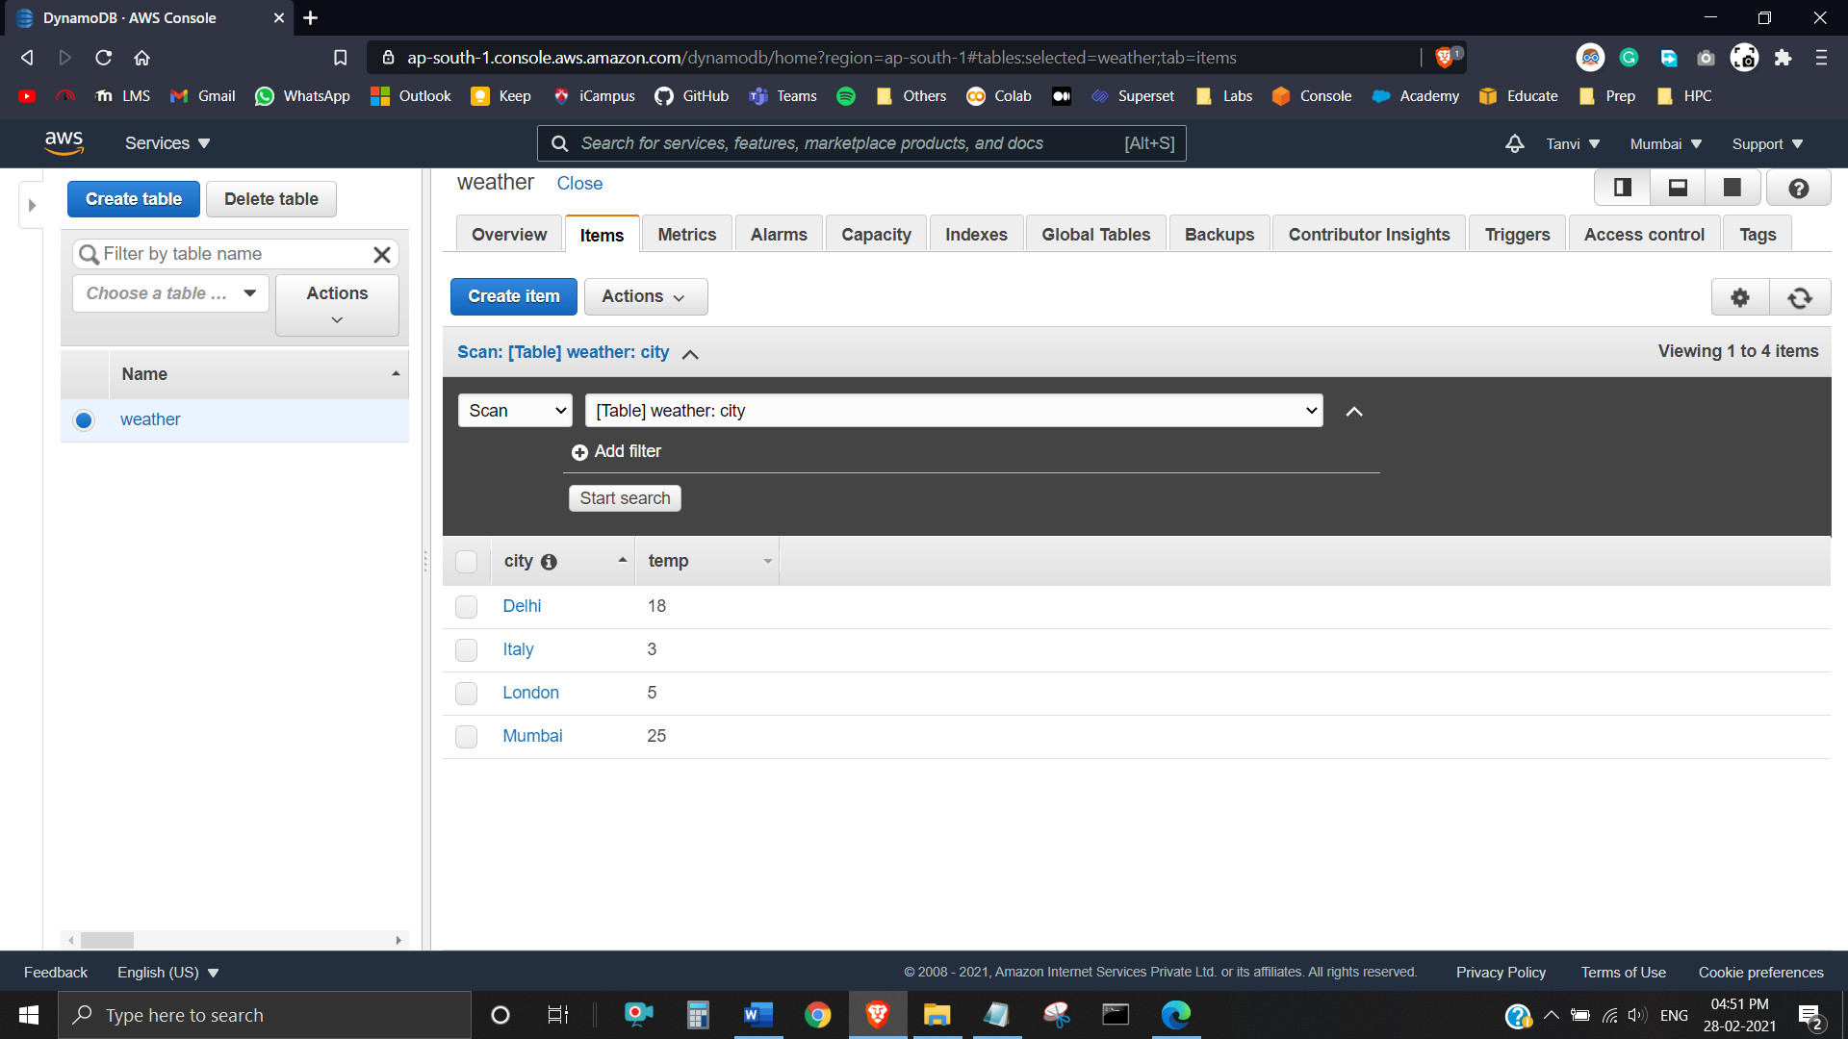

**Task 5**

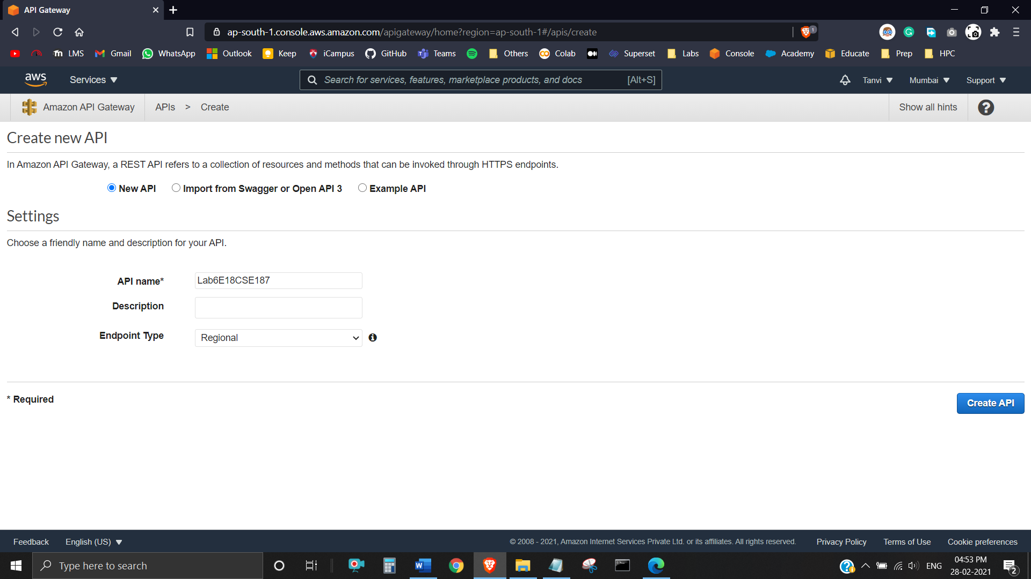

**Task 6**

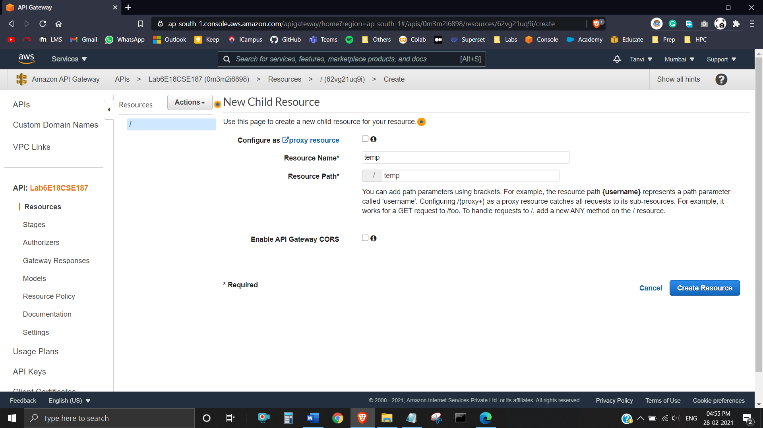

**Task 7**

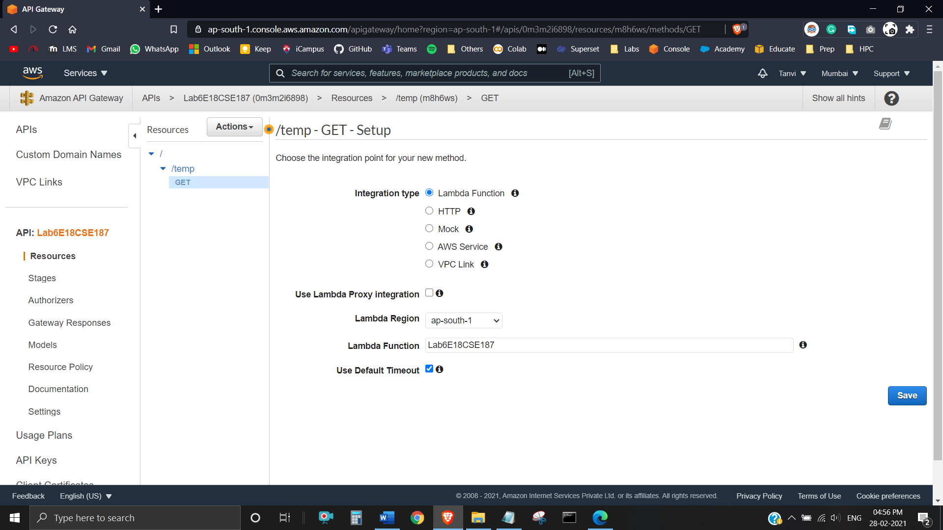

**Task 8**

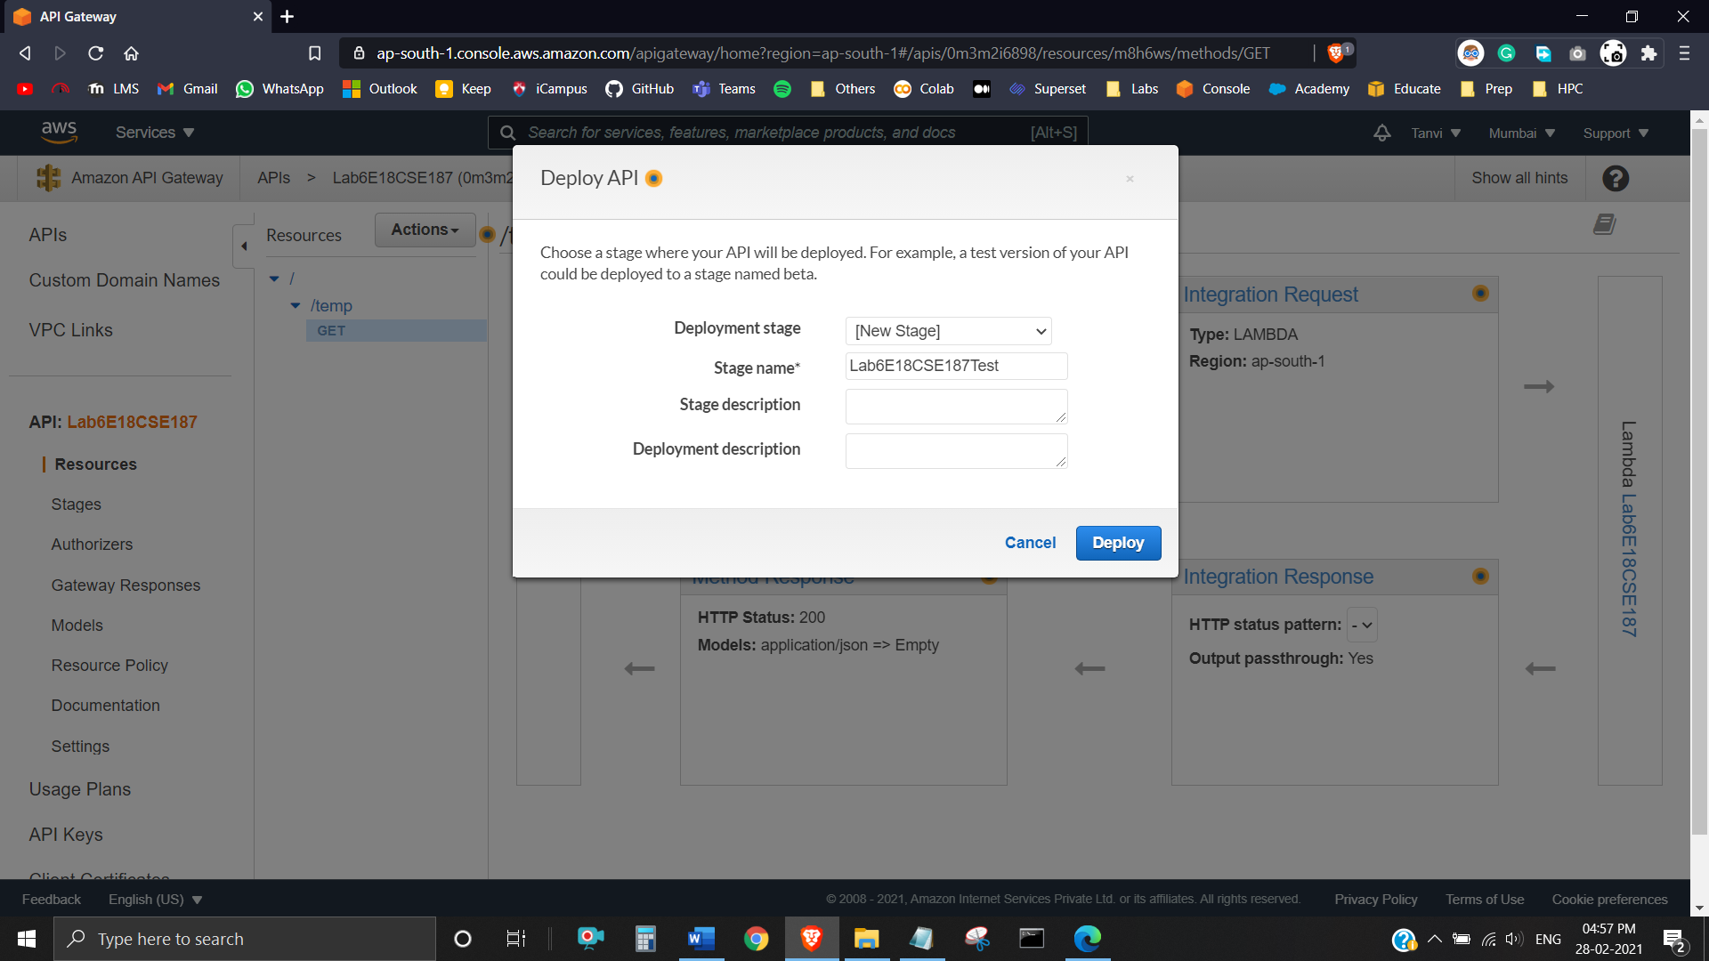

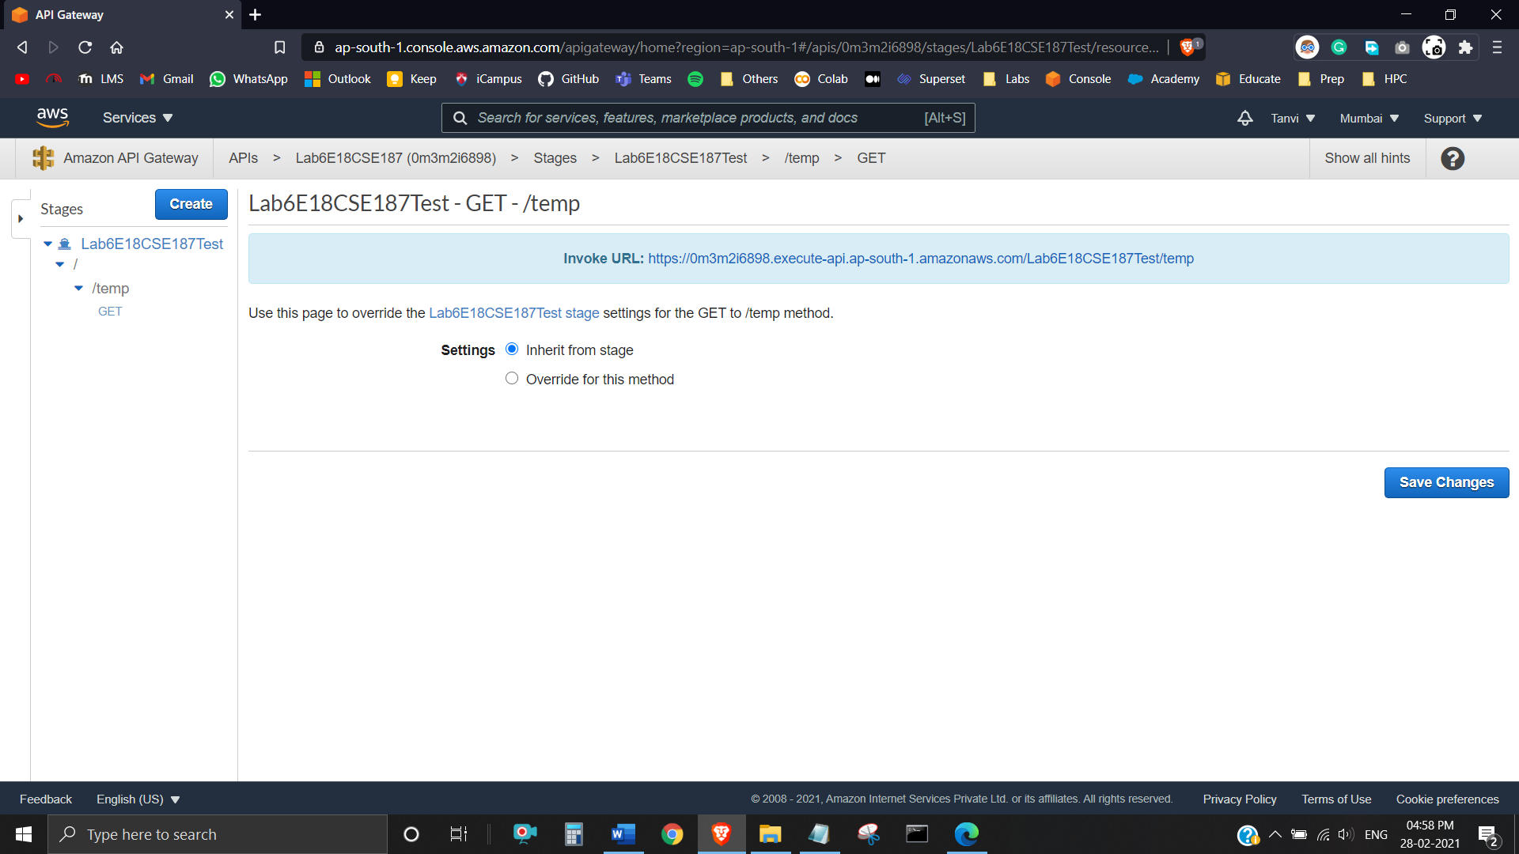

**Task 9**

